**Ten Instructional Strategies**

**Graphic Organizers**

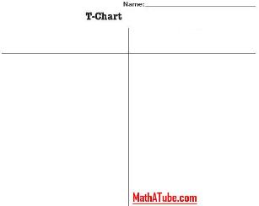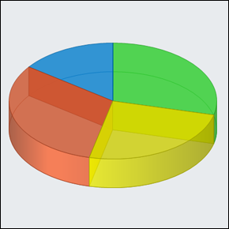

**Advance Organizers**

**Examples and Non-examples**

|  |  |
| --- | --- |
| Example of BIG | Non-example of BIG |
|  |  |

**Compare and Contrast**

|  |  |
| --- | --- |
| * | * |
| **Drink** | **drink** |
| **White** | **orange** |
| **from a cow** | **from a fruit** |

**Red - what they have in commom Blue - what they don’t have in common**

**Higher Level Questions**

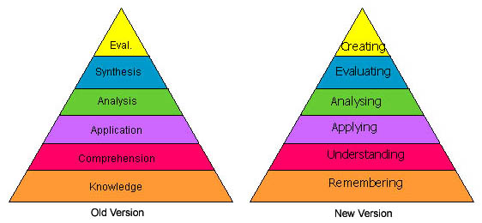

**Games**

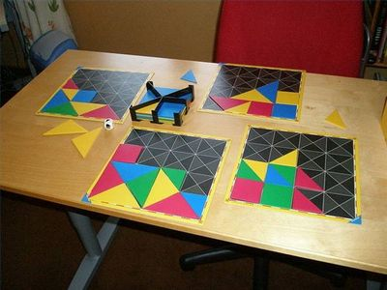

**Think-Pair-Share**

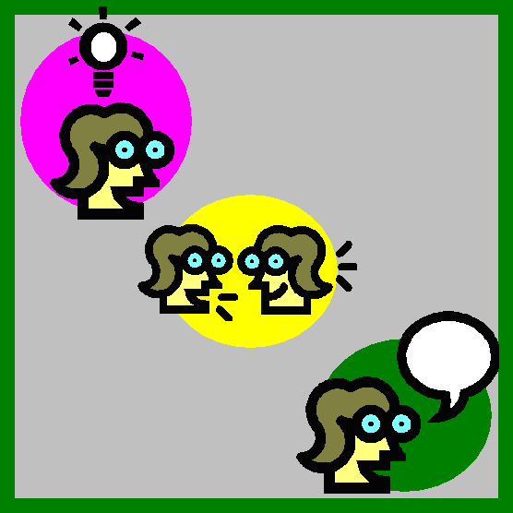

**Jigsaw**

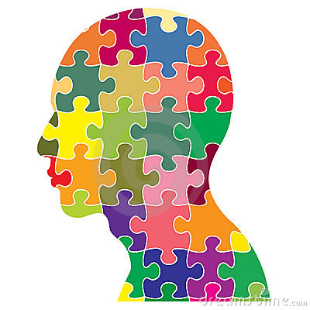

**Formative Assessment**

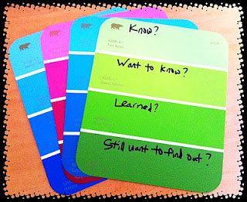

**Summative Assessment**

